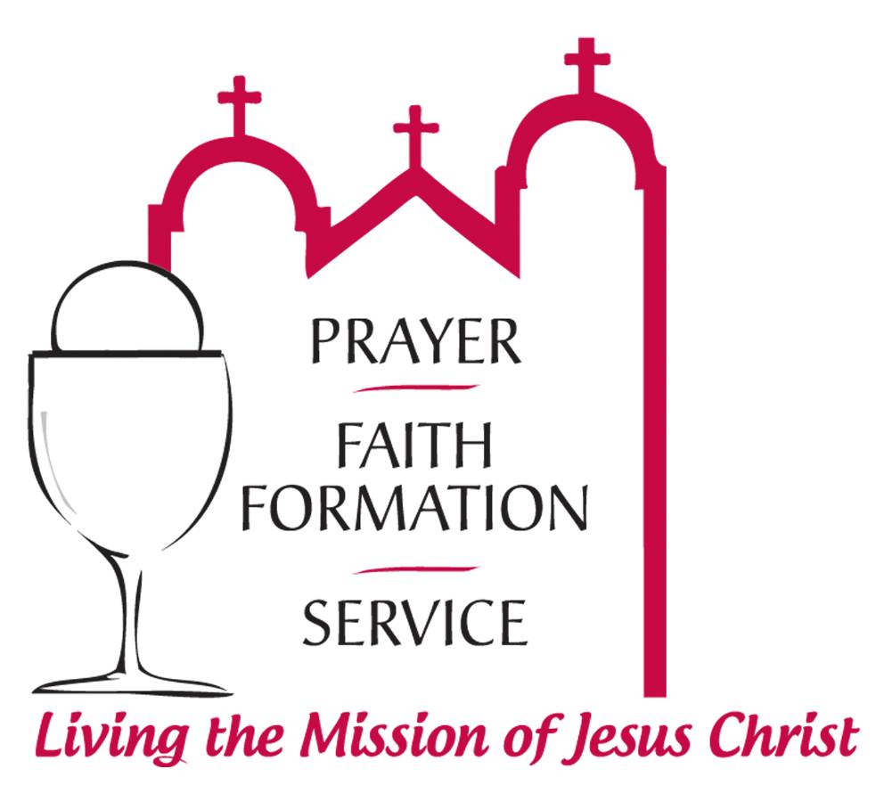

A Preliminary Case Statement in Support of
Our Plans for Expanding & Renovating Our Church Facilities & the Future Construction of a New Sacred Heart Church

Sacred Heart Parish
Owatonna, MN

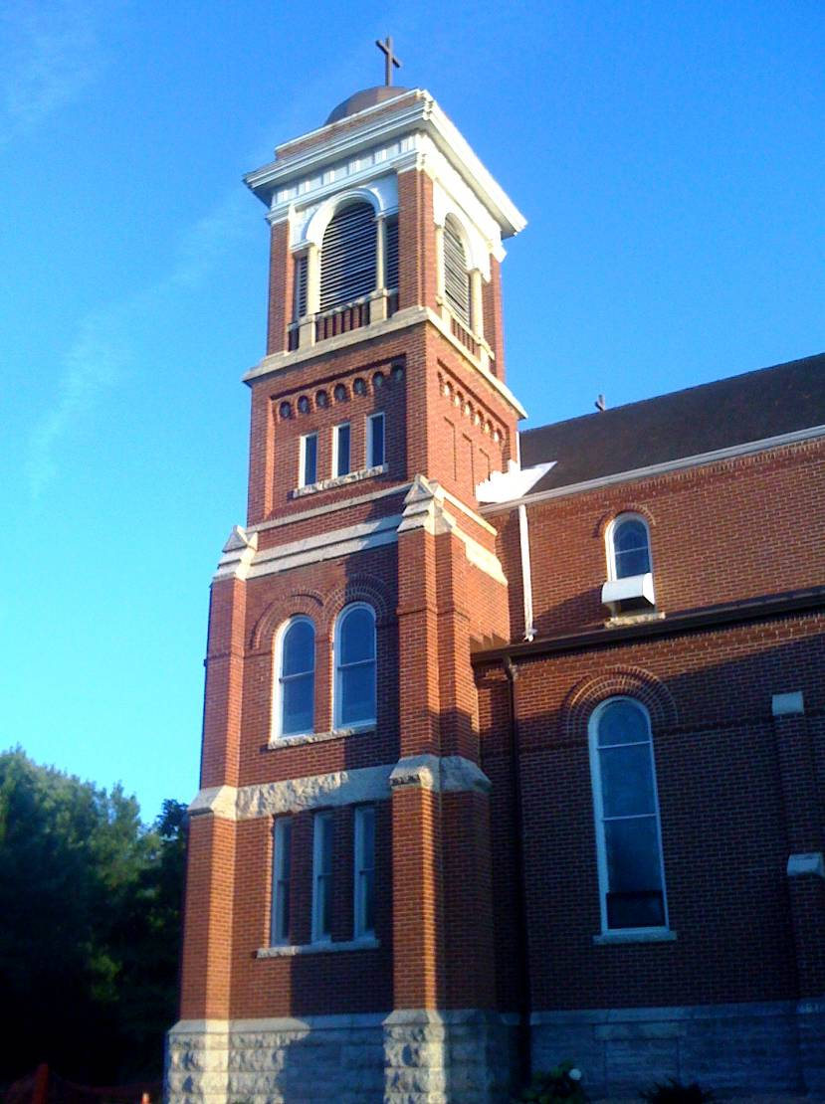

Introduction

Sacred Heart Parish, founded in 1866, has a long and proud history that spans almost five generations. And in just 4 years we will be celebrating our sesquicentennial, 150 years of serving our God and our community. While facilities and faces have certainly changed during that time, one thing remains the same…our commitment to Christ, to one another, and to the betterment of our community.

As a result, our parish today is an active and increasingly vibrant Catholic parish. We’ve seen the Church almost double in members over the past twenty years from 750 families to over 1200 today. Led by a dedicated pastor, associate pastor and a strong corps of lay leaders and volunteers, there are an increasing number of ways that people of all ages and backgrounds are participating in the spiritual, educational, social and service ministries of our community.

Our Needs

Meeting, Greeting and Education Space

The economic vitality of our community and the quest for small town living has blessed Owatonna’s rural atmosphere with steady growth and a positive outlook for the future. This economic growth has already translated to parish growth and an increased use of our parish facilities.

While we are blessed to have our parish community and ministries flourishing, we also realize that our church facilities are 90 years old and were built for a much smaller parish. In attempting to meet the needs of our burgeoning faith family, our facilities have been stretched to their limits and beyond. Our lack of adequate space is having an adverse effect on our ability to serve our members effectively and will become an ever increasing problem in the future.

Our Church Leadership realized this and actually began discussions about expanding for the future back in 2006. With this in mind, the Sacred Heart Facility Planning Team developed a 3 Year and 20 Year Master Plan for the parish to address and prioritize our needs.

“God calls us to care for
and cultivate all that He
has given us…not to be complacent, but rather to constantly strive to be
better, to build on and improve what we have…always trying to realize our God-given potential.”
- It’s truly a blessing to have such an energetic, busy parish, so much so that our current facilities just can’t accommodate the growing number of committees, ministries, organizations and activities that our parish participates in. We hear a consistent plea for more classroom, program and meeting space, so we can be more effective in fulfilling our mission, serving the needs of parishioners and doing God’s work. Ministries like Youth Ministry and others don’t have adequate space to meet. In short, we lack classrooms and meeting rooms that many of our Church groups require and this lack of space has forced some groups to meet in various inconvenient and less appropriate spaces such as the Rectory Basement in the church.

- Future expansion to accommodate parish growth may be inhibited at our present site as we are becoming land locked. We need to examine our options to address this concern.

Church Renovation
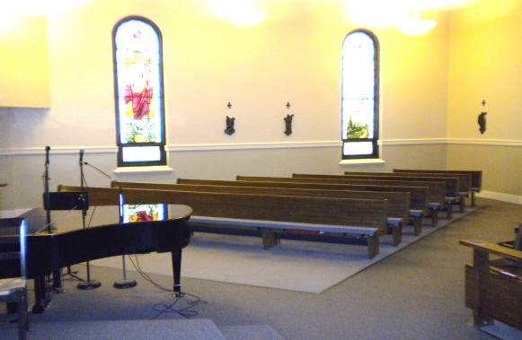
- We need to improve seating capacity and sight lines in the church. There are too few seats at busy Masses and at Christmastime and Easter. Pews are arranged in traditional formation with the back pews a good distance from the altar. This makes it difficult for people in the back to see and hear clearly. It also inhibits full and active participation in our liturgies.

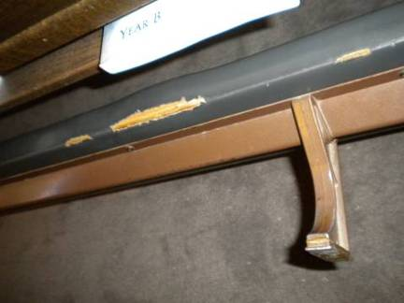
- The pews and kneelers in the church are worn out and need to be replaced as does the carpeting.
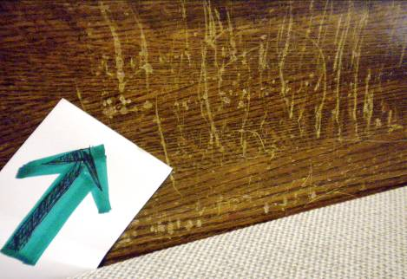

Expanded Narthex

- We’ve also outgrown our Narthex or Gathering Space. It no longer provides us with a large enough, warm and welcoming gathering space where people can meet and greet people before and after Masses and other special and sacred celebrations held in our church.

- The limited size of the existing narthex also doesn’t allow us enough room to adequately display or disseminate information about various and varying parish services and activities.

Expanded More Suitable Parish Offices

- Our present parish offices are located in the north half of the Rectory. The first floor living space has been converted and subdivided into maze of small and inefficient offices that are inadequate and not ADA compliant.

Private Living Quarters for Our Priest

- Our priests’ living quarters are located on the second level, above the parish offices. This does not provide adequate privacy for our resident or visiting priests.

Maintenance Issues

We also have a number of maintenance issues that need to be addressed either now or soon.

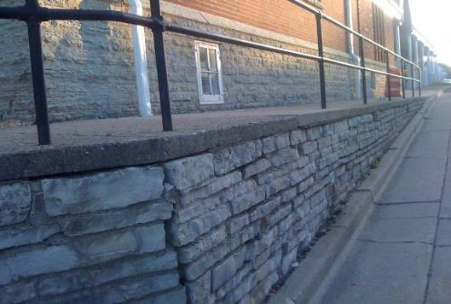
- The roof is in need of repair and there is a considerable amount of re-pointing needed on the masonry.

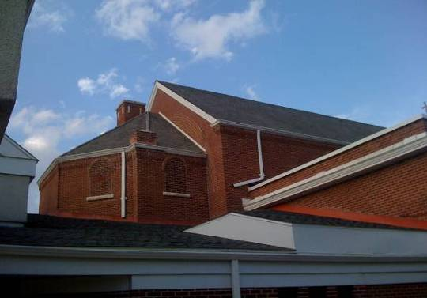

- The HVAC system is aging and inefficient which increases our operational costs.

- Additional restrooms are needed beyond the ones that are located on the main level now.

- There is currently no internet, audio, video capability in the meeting rooms and Parish Center.

- Parking is inadequate and the main lot slopes toward the building which causes various water issues both in our parking lot and damage to our parish buildings.

Our Plans

“Just as our forefathers and mothers sacrificed to make our church better, we are called to do likewise for those who will follow.”
To address these critical needs, parish leadership has developed an exciting action plan that could be done in two phases. Our vision is to renovate and expand our facilities to meet our current and short term future needs and ultimately create a new Parish Campus that will enable us to minister to future generations of parishioners even more effectively and efficiently.

Our original plan was to buy the former hospital property to the south of the Church from the City. This would have provided the church with more than enough ample room for expansion. Permission was received from the Diocese to proceed with the purchase, but the City did not accept our offer. They wanted to sell this property to a tax paying entity. Recently, you may have heard that Fareway Foods has entered into an agreement to purchase and re-develop the hospital property for a new grocery store.

With the Hospital plan off the table, our Planning Team came up with an alternative plan.

Phase One

The first phase of our revised Master Plan would include renovation of our church; expansion of and enhancements to our parish center to include additional gathering space, a new parish office center and expanded and enhanced class and meeting room space. It also includes various other improvements to buildings and grounds.
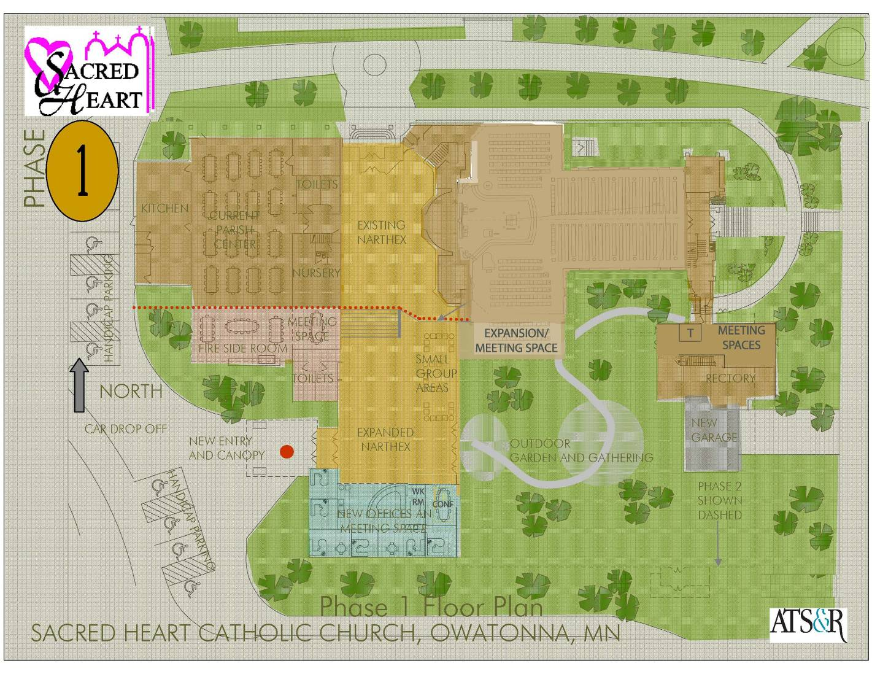

Church Renovations

Renovations in the Church itself would include:

- Reconfiguring the existing pews and angling the pew sections in the front of the church to improve sight lines. This would add approximately 50 seats and provide for overflow seating.

- Replacing the existing pews and carpeting and recovering the kneelers.

- Enlarging the altar platform to bring the clergy closer to the assembly which will help to improve sightlines, sound and create a more intimate, participatory environment in our liturgies.

Parish Center Enhancements

Our first phase of our plan also includes expanding our Parish Center to the south into our existing parking lot and making various other enhancements within. This will create 3,000 square feet of additional space for an expanded narthex, parish offices and expanded meeting space.

Expanded Narthex

- The narthex will be expanded to the south which will provide additional space for greeting and getting to know one another better after Masses and various other types of services that are held in our church.

- This additional space will also provide adequate space to set up tables and various other displays to showcase and distribute information about various and varying parish services and upcoming activities.

- This additional, flexible space will also provide adequate break-out space for various parish classes and meetings.

Parish Office Center

- Expansion of our parish center will also provide space for a parish office center, a new suite of parish offices that are more modern and adequate for our staff in a location that is more visible and accessible to all parishioners and visitors.

Return of the Rectory to a Private Residence

- Our new parish office center will also enable us is to return our rectory to its originally intended use as private living quarters for our resident and visiting priests.

Expanded and Modernized Meeting Space

- The expanded Parish Center will also provide expanded program meeting and classroom space, a new Fireside Meeting Room and new restrooms as well.

- Additional and more flexible meeting space will also be created by adding a modern room divider system to the current Parish Center that would subdivide the space and provide versatility when needed.

- Modernizing the existing meeting and class rooms with up-to-date technology and furnishings is also included in our plans.

Other Improvements

Other planned phase one improvements include:

- Updating our HVAC system to one that is more effective, energy and cost efficient.

- Re-roofing and tuck pointing our building to protect our newly expanded and renovated facilities.

This new addition will also enable us to correct various traffic flow, parking and parking lot deficiencies, improve storm water management and make various other enhancements to our buildings and grounds. For example:

- Marian Drive would be closed off to make the school more secure.

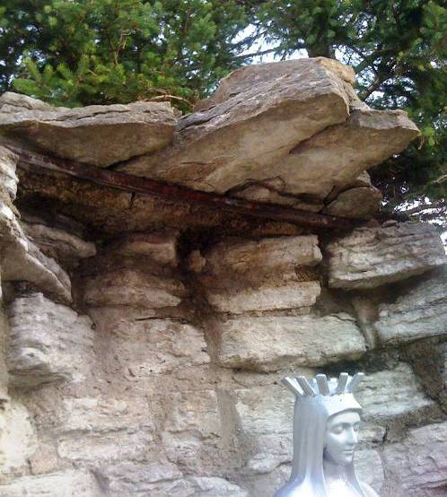
- The Shrine, which is in need of repair already, would be re-located and refurbished.
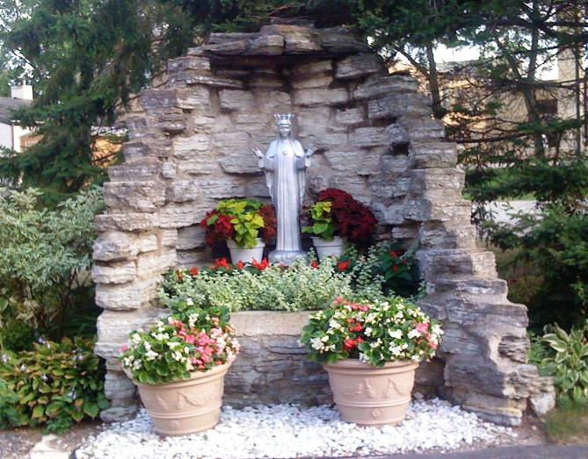
- The existing garage will be removed creating a wonderful new green space for outdoor gathering and worship between the existing Rectory and the Parish Center addition.

- Finally, to address the need for expanded parking, we plan to purchase four neighboring homes that border our property, one on Cedar Avenue and three on Oak Avenue. This will provide for additional on-site parking, a new entrance to our property from Cedar Avenue and future needed expansion.

- Working closely with the City and Fareway Foods, we have been able to arrange several concessions for the re-development of the hospital property.

- Fareway has agreed to design the store so that its loading docks would not face our church property.

  - Fareway has also agreed to pay for the demolition of three of the houses that we plan to purchase which will result in a $125,000 savings.

  - Fareway is closed on Sundays and has agreed to let us use their parking lot for expanded parking for our members.

  - And they will include a new driveway easement from Cedar Avenue that is in our Master Plan and will be needed with the closing of Marian Drive.

The cost of phase one of our Master Plan is estimated to be in the $2.8 million range.

Phase Two
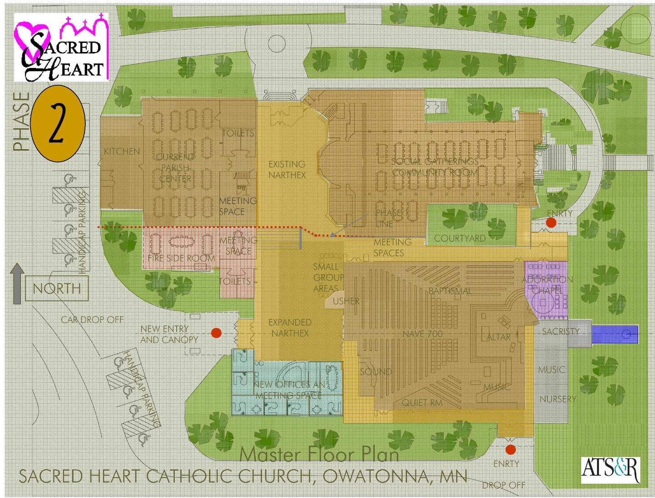

Phase two of our master plan will include:

- Demolition and relocation of the priest’s rectory to a new, nearby off-site location freeing space for a new church.

- Construction of an all new church adjacent to our existing church that will expand our seating capacity from 450 to 700 seats, which will connect with the expanded narthex, provide a more intimate Daily Mass and Eucharistic Adoration Chapel and meet our needs for the foreseeable future.

- Conversion of the existing church into a more expansive fellowship hall.

The cost of phase two of our Master Plan is estimated to be in the $9.3 million range.

Costs and Campaign

The total cost for addressing these various needs is estimated to be in the $12 million range, an amount that we would plan to raise in a specially conducted capital campaign where members would be asked to prayerfully consider special gifts – over and above their current gifts to the church – in support of this special project and need.

Gifts to the campaign could be made in a number or combination of ways. Pledges over a three-year period would be minimally encouraged and probably essential to meeting our needs since it would be impractical, if not impossible, to reach a goal of this magnitude with one time, out-of-pocket gifts. Non-cash gifts such as securities, real estate and personal property would also be accepted and encouraged as would deferred gifts, such as life insurance policies, gifts in trust and gifts through one’s estate.

Summary

Through the generous prayerful, volunteer and financial support of many – and the extraordinary support of a few – we believe that we can succeed in our task. As a result, we are also confident of our continued growth as a community of faith and in our ability to even better do God’s will and works. So thank you for your support in advance.

